**DIGITAL TWIN BASED REAL-TIME   
AUGMENTD VISON SYSTEM FOR HEALTHCARE**

**ABSTRACT:**

The Project proposes real-time health data monitoring with **Digital Twin** with **Augmented Vision** for the ICU emergency treatment patients, suggesting that this symptom could be used as screening tool to help identify people with potential high-risk cases who could be recommended to treat immediately.

For faster treatment in a hospital, it generates a scan able **Augmented Vision (AV) code** print. Also, the wearable bio-medical sensor data’s also uploading to server system by IoT. By our proposed system, every patient is being addressed by their unique DT based AV **code** with them**.**

Whenever people are admitted with severe problems in hospitals such as heart pain, lung problem etc they will be provided with the AV code and wearable sensors and will be admitted in ICU. In among the many peoples in the treatment in the hospital, the senior as to inspect everyone for the treatment in emergency manner to treat him faster and save their life.

they have to show their own **DT code** to the(Fig3) **DT vision camera cum scanner** available,immediately the **DT vision Software System** fetch the respective persons biomedical senor values from the server also according to the current sensor values and database data’s the DT **vision Software System** will show us the details in real-time images as shown in fig(1) and fig(2) for normal datasets i.e. green DT images for entry permitted persons and red MR images for the lung affected Persons with the data sets respectively .

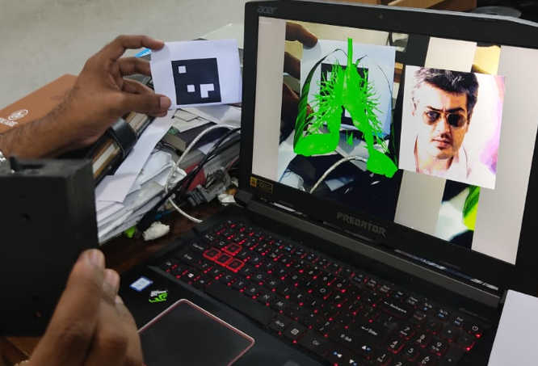 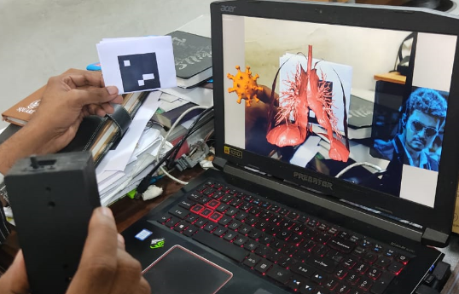

**Fig (1) Fig (2)**

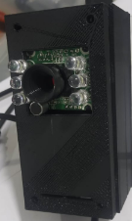

**Fig (3)**

**DT**

**Vision**

**Camera  
Block Diagram:**

**Wearable Sensor Unit:**

Liquid Crystal

Display

ATMEGA328

Controller

**Body Temperature**

**Sensor**

IoT

Board

UART

Converter

**Pulse/SPO2**

**Sensor**

Alarm Unit

**Respiratory**

**Sensor**

Power Unit

**Scanning ans Server data base Monitoring Unit or Mobile app:**

**PC /laptop or Mobile with apk:**

PC/ Laptop

(Server IoT Database with

DT Vision Software)

U

S

B

**Hardware Requirements:**

1. ATMega328 controller

2. Body Temperature Sensor

3. Sound (Cough) sensor

4. IoT – NodeMcu

5. LCD

6. Buzzer

**Software Requirements:**

1. Arduino IDE

2. Embedded C language

**Proposed System:**

1. First time in Technology **DT Vision** system utilizes for the real-time update and track of people.

2. The Images based output and tracking with DT vision system.

**Existing System:**

1. No database based system available to compare or to analyse a person’s history of tracking and biomedical data.

2. No updated technology for scanning like AR, VR and MR.

3. No image based output in current method.

**Applications:**

1. Healthcare system

2. Plant disease

3. Machine health